DATE:
Online Hotel Room Booking Website
1. Aim
To design and develop a responsive Online Hotel Room Booking Website using HTML and CSS that allows users to view room details, check room information, register, manage bookings, and access hotel services. It also provides an admin interface to manage room details, prices, availability, and booking information.
2. Software Required
- Operating System: Windows
- Front-end Technologies: HTML5 and CSS3
- Code Editor: Visual Studio Code / Notepad++
- Web Browser: Google Chrome / Microsoft Edge
3. Algorithm
- Start the program.
- Create the home page using HTML.
- Design the website layout using CSS.
- Display hotel information and the four types of rooms with their prices and amenities.
- Create a user registration and login page.
- Create a search form to enter the destination, check-in date, check-out date, and number of guests.
- Design a room listing page to display room details and booking options.
- Create a booking form to collect customer details and booking dates.
- Design pages for booking history, profile management, booking modification, and cancellation.
- Create an admin page to manage room quantities, prices, and booking details.
- Add static pages for About Us, Contact Us, Customer Service FAQs, Local Travel Guide, and Privacy Policy.
- Link all pages using HTML hyperlinks and apply CSS styling to make the website responsive.
- Save all files and open the home page in a web browser.
- Verify the page layout, navigation links, and forms.
- Stop the program.

HTML:

<!DOCTYPE html>
<html lang="en">
<head>
<meta charset="UTF-8">
<meta name="viewport" content="width=device-width, initial-scale=1.0">
<title>Grand Stay - Hotel Booking</title>
<link rel="stylesheet" href="style.css">
</head>
<body>
<header>
<h1>Grand Stay Hotel</h1>
<p>Your comfort, our priority</p>
<nav>
<a href="#home">Home</a>
<a href="#search">Search Rooms</a>
<a href="#account">Account</a>
<a href="#bookings">My Bookings</a>
<a href="#admin">Admin</a>
<a href="#information">Hotel Information</a>
</nav>
</header>

<main>
<section id="home" class="hero">
<h2>Find Your Perfect Stay</h2>
<p>Comfortable rooms at affordable prices.</p>
<a class="button" href="#search">Book a Room</a>
</section>

<section id="search">
<h2>Search Hotel Rooms</h2>
<form id="searchForm">
<label>Destination</label>
<input id="destination" value="Chennai" required>

<label>Check-in Date</label>
<input type="date" id="checkin" required>

<label>Check-out Date</label>
<input type="date" id="checkout" required>

<label>Number of Guests</label>
<input type="number" id="guests" min="1" value="1" required>

<button type="submit">Check Availability</button>
</form>
<div id="roomList" class="room-grid"></div>
<p id="searchMessage"></p>
</section>

<section id="account">
<h2>User Account</h2>
<div class="two-columns">
<form id="registerForm">
<h3>Register</h3>
<label>Full Name</label>
<input id="regName" required>
<label>Email</label>
<input type="email" id="regEmail" required>
<label>Password</label>
<input type="password" id="regPassword" minlength="6" required>
<button type="submit">Register</button>
</form>

<form id="loginForm">
<h3>Login</h3>
<label>Email</label>
<input type="email" id="loginEmail" required>
<label>Password</label>
<input type="password" id="loginPassword" required>
<button type="submit">Login</button>
</form>
</div>

<div class="card">
<h3>My Profile</h3>
<p id="currentUser">Please register or log in.</p>
<form id="profileForm" hidden>
<label>Full Name</label>
<input id="profileName" required>
<label>Email</label>
<input id="profileEmail" type="email" required>
<button type="submit">Update Profile</button>
</form>
<button type="button" id="logoutButton">Logout</button>
</div>
<p id="accountMessage"></p>
</section>

<section id="bookings">
<h2>My Booking History</h2>
<div id="bookingList"></div>
</section>

<section id="admin">
<h2>Administrator Panel</h2>
<p>Demo admin login: <b>admin@hotel.com</b> / <b>Admin123!</b></p>
<p>Log out of the user account before logging in as the administrator.</p>

<form id="adminLoginForm">
<label>Admin Email</label>
<input type="email" id="adminEmail" required>
<label>Admin Password</label>
<input type="password" id="adminPassword" required>
<button type="submit">Admin Login</button>
</form>

<div id="adminPanel" hidden>
<h3>Manage Room Types</h3>
<form id="roomAdminForm">
<label>Room Type</label>
<select id="adminRoomType"></select>
<label>Price per Night (₹)</label>
<input id="adminPrice" type="number" min="1" required>
<label>Number of Rooms</label>
<input id="adminQuantity" type="number" min="0" required>
<button type="submit">Update Room Details</button>
</form>

<h3>Manage All Bookings</h3>
<div id="adminBookingList"></div>
<button type="button" id="adminLogout">Admin Logout</button>
</div>
<p id="adminMessage"></p>
</section>

<section id="information">
<h2>Hotel Information</h2>

<article class="card">
<h3>About Us</h3>
<p>Grand Stay is a sample hotel booking website designed to provide
comfortable accommodation for families, students and business travellers.</p>
</article>

<article class="card">
<h3>Room Types</h3>
<ul>
<li>Standard Room - Basic facilities for a comfortable stay.</li>
<li>Deluxe Room - Spacious room with extra amenities.</li>
<li>Suite Room - Premium room with a separate sitting area.</li>
<li>Family Room - Extra space for families and groups.</li>
</ul>
</article>

<article class="card">
<h3>Contact Us</h3>
<p>Email: support@grandstay.example</p>
<p>Phone: +91 90000 00000</p>
<p>Address: Chennai, Tamil Nadu, India</p>
</article>

<article class="card">
<h3>Customer Service - FAQs</h3>
<details>
<summary>How do I book a room?</summary>
<p>Search rooms, choose a room type and select Book Now.</p>
</details>
<details>
<summary>Can I cancel my booking?</summary>
<p>In this demo, cancellation is allowed at least 3 days before arrival.</p>
</details>
<details>
<summary>Can I change my booking?</summary>
<p>Yes. Use the Modify button at least 3 days before arrival.</p>
</details>
</article>

<article class="card">
<h3>Local Travel Guide</h3>
<p>Explore Marina Beach, museums, shopping areas and local restaurants
when visiting Chennai. Check transport schedules before travelling.</p>
</article>

<article class="card">
<h3>Privacy Policy</h3>
<p>This classroom demo stores sample information in your browser.
Do not enter real passwords, payment details or sensitive personal data.
A production website requires a secure backend and a complete privacy policy.</p>
</article>
</section>
</main>

<footer>
<p>&copy; 2026 Grand Stay Hotel | Internet Programming Lab Project</p>
</footer>

<script src="script.js"></script>
</body>
</html>
CSS:

* {
box-sizing: border-box;
}
html {
scroll-behavior: smooth;
}
body {
margin: 0;
font-family: Arial, sans-serif;
background: #f4f7fb;
color: #263445;
line-height: 1.6;
}
header {
background: #12304a;
color: white;
text-align: center;
padding: 24px 12px;
}
header h1 {
margin: 0;
}
nav {
display: flex;
justify-content: center;
flex-wrap: wrap;
gap: 10px;
margin-top: 18px;
}
nav a {
color: white;
text-decoration: none;
padding: 8px 12px;
border-radius: 5px;
}
nav a:hover {
background: #275779;
}
main {
width: 92%;
max-width: 1100px;
margin: 25px auto;
}
section {
background: white;
padding: 24px;
margin-bottom: 25px;
border-radius: 10px;
box-shadow: 0 3px 12px #0000000d;
scroll-margin-top: 15px;
}
.hero {
text-align: center;
padding: 55px 20px;
background: #dcecf8;
}
.hero h2 {
font-size: 32px;
}
.button {
display: inline-block;
text-decoration: none;
background: #087e8b;
color: white;
padding: 10px 18px;
border-radius: 5px;
}
form {
display: flex;
flex-direction: column;
gap: 9px;
margin-bottom: 20px;
}
input, select {
width: 100%;
padding: 11px;
border: 1px solid #cbd5df;
border-radius: 5px;
font-size: 15px;
}
button {
background: #087e8b;
color: white;
border: 0;
padding: 11px 15px;
border-radius: 5px;
cursor: pointer;
margin-top: 5px;
}
button:hover {
background: #05616b;
}

button:disabled {
background: #888;
cursor: not-allowed;
}

.two-columns, .room-grid {
display: grid;
grid-template-columns: repeat(2, minmax(0, 1fr));
gap: 20px;
}

.card, .room-card, .booking-card {
background: #f8fafc;
border: 1px solid #dce3eb;
padding: 17px;
margin: 12px 0;
border-radius: 8px;
overflow-wrap: anywhere;
}

.room-card h3, .booking-card h3 {
color: #12304a;
}

small, .muted {
color: #526579;
}

footer {
background: #12304a;
color: white;
text-align: center;
padding: 15px;
}

[hidden] {
display: none !important;
}

@media (max-width: 650px) {
.two-columns, .room-grid {
grid-template-columns: 1fr;
}

main {
width: 96%;
}

section {
padding: 16px;
}

.hero h2 {
font-size: 25px;
}

nav {
flex-direction: column;
}
}

OUTPUT:
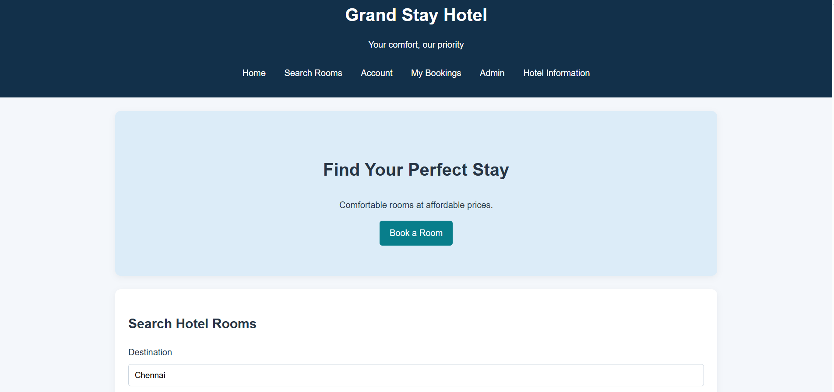
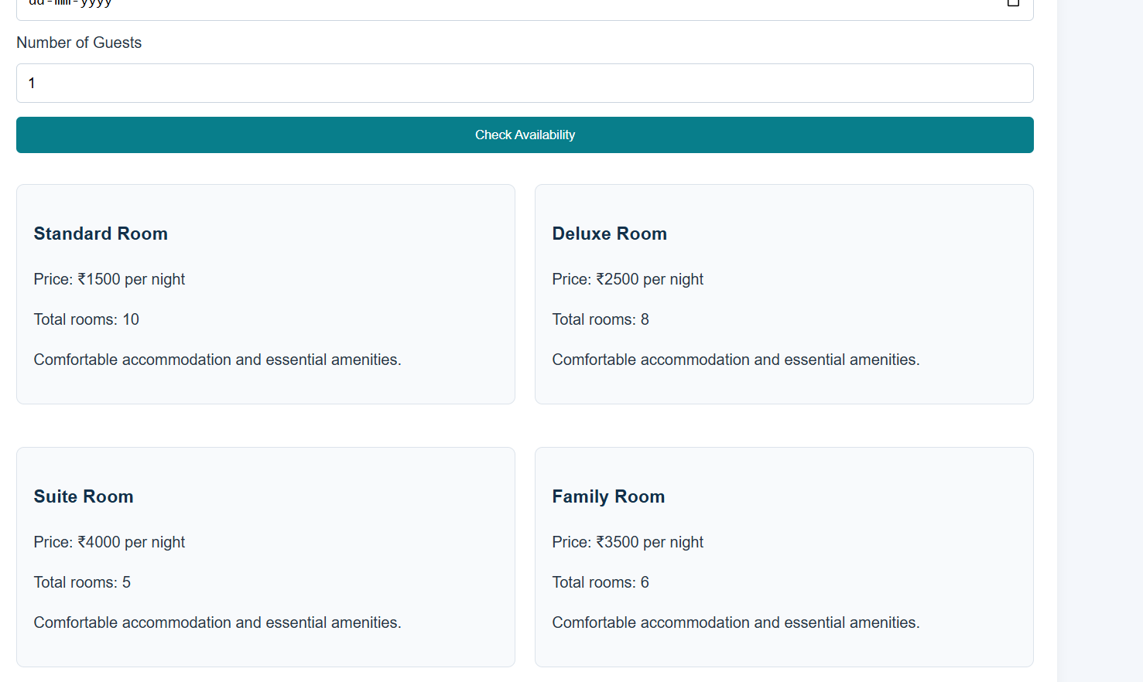
4. Result
Thus, the Online Hotel Room Booking Website was designed using HTML and CSS. The website provides pages for user registration, login, room information, booking forms, booking history, profile management, and administration. It also includes hotel information, customer support, travel guides, and privacy policy pages.

